SIEM IN PRACTICE

LAB 02: SPLUNK – EXPLORING SPL
Internship: DG Interns HUB – Cybersecurity Internship
Platform: TryHackMe
Room Name: Splunk: Exploring SPL
Category: SIEM / Security Operations Center (SOC)
Tool Used: Splunk Enterprise
Language: Search Processing Language (SPL)

1. OBJECTIVE
The main objective of this lab was to understand Splunk Search Processing Language (SPL) and learn how to search, filter, organize and analyze security log data.
The lab focused on using SPL commands to identify suspicious activities, analyze events, calculate statistics and detect unusual login behaviour.

Learning Objectives
- Understand the basics of SPL.
- Learn how to search security events.
- Understand search operators and filtering commands.
- Learn how to structure and organize search results.
- Perform statistical analysis using SPL.
- Understand event correlation using subsearches.
- Identify unusual activities using anomaly detection.
- Understand how Splunk helps SOC analysts investigate security incidents.

2. INTRODUCTION TO SPLUNK
Splunk is a SIEM and data analytics platform used to collect, search, monitor and analyze machine-generated data.
It helps security analysts investigate system logs, network events and security activities.

What is SPL?
SPL stands for Search Processing Language.
It is the language used in Splunk to search, filter, transform and analyze machine data.

Importance of SPL
- Searches large amounts of log data.
- Filters unnecessary events.
- Identifies suspicious activities.
- Calculates event statistics.
- Creates tables and visualizations.
- Helps detect security threats.

3. SPLUNK SEARCH AND REPORTING
The Search and Reporting application is the main interface used to search and analyze log data in Splunk.

Important Components
- Search Head: Used to enter and execute SPL queries.
- Time Picker: Selects the time range for searching events.
- Search History: Displays previously executed searches.
- Data Summary: Displays information about available hosts, sources and sourcetypes.
- Fields Sidebar: Displays selected and interesting fields extracted from events.

Understanding Indexes
An index is a storage location used by Splunk to organize collected data.
During this lab, the windowslogs index was used to search Windows event logs.
Example:
index=windowslogs
This query retrieves events from the windowslogs index.

4. SEARCH OPERATORS
Search operators help analysts create conditions and narrow down search results.

Important Search Operators

Operator | Meaning
AND | Both conditions must match
OR | Either condition can match
NOT | Excludes matching values
= | Checks an exact field value
!= | Checks values that are not equal
> | Greater than
< | Less than
>= | Greater than or equal
<= | Less than or equal
" " | Searches an exact phrase
( ) | Groups search conditions
* | Wildcard matching

Examples
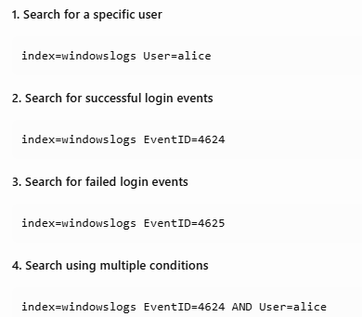

5. FILTERING RESULTS
Filtering commands help remove unnecessary information and display relevant events.

Important Filtering Commands
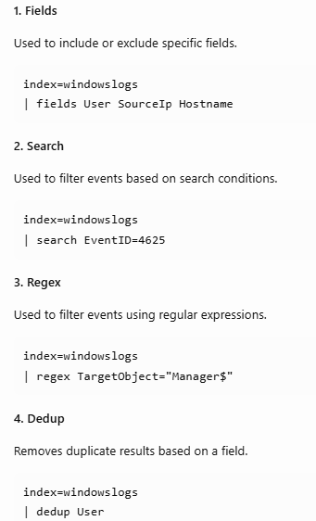

Importance of Filtering
- Reduces unnecessary search results.
- Makes investigation easier.
- Helps identify relevant security events.
- Saves investigation time.

6. STRUCTURING RESULTS
Structuring commands help organize raw events into a readable format.

Important Commands
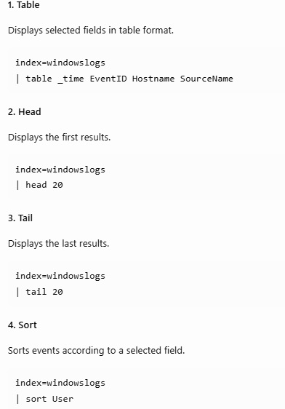
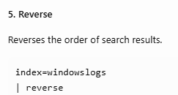
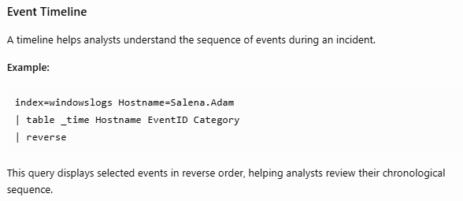

7. TRANSFORMING COMMANDS
Transforming commands convert raw event data into useful statistics and summaries.

Important Commands
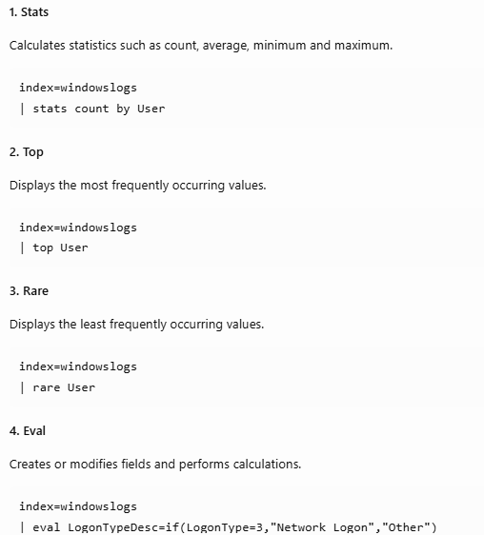
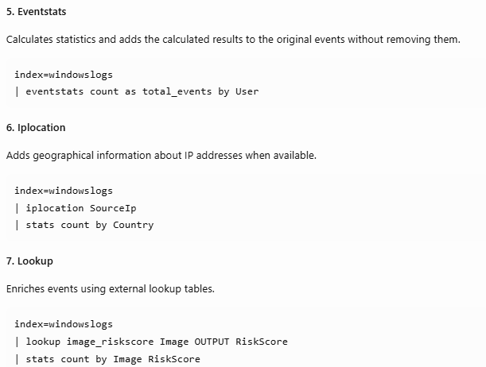

Benefits of Transforming Commands
- Summarizes large datasets.
- Identifies frequent and rare activities.
- Helps identify unusual events.
- Supports security investigations.
- Improves data visualization.

8. SUBSEARCHES AND EVENT CORRELATION
A subsearch is a search performed inside another search.
It helps analysts combine information from different events or data sources.

Example
A SOC analyst wants to connect Sysmon process creation events with Windows successful login events.
The common LogonId field can be used to correlate the events.

Example SPL Query:
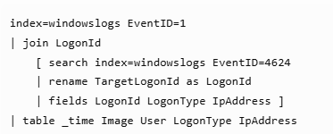

Explanation
- Event ID 1 identifies Sysmon process creation.
- Event ID 4624 identifies successful Windows logons.
- LogonId connects the related events.
- LogonType provides information about the type of login.
- IpAddress helps identify the login source.

Importance
- Connects related events.
- Helps reconstruct user activities.
- Supports incident investigation.
- Provides additional context about suspicious processes.
Note: Join and subsearch operations can be resource-intensive on large datasets, so efficient alternatives such as stats may be preferable.

9. ANOMALY DETECTION
Anomaly detection is the process of identifying activities that are different from normal or expected behaviour.
It helps SOC analysts identify potentially suspicious activities.

Example
An employee normally logs in from India during working hours.
Suddenly, the same account logs in from an unexpected country.

This activity may indicate:
- Compromised credentials.
- Unauthorized account access.
- VPN usage.
- Suspicious login behaviour.

Detecting Unusual Login Countries
Example SPL Query:
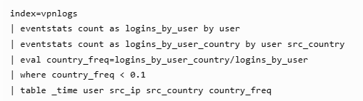

Explanation
- eventstats calculates total logins.
- eval calculates login frequency.
- where identifies unusual country activity.
- table displays the suspicious login details.

Detecting Unusual Login Hours
Another method is identifying logins that occur at unusual times.
For example, if an employee normally logs in around 9 AM but suddenly logs in at 3 AM, the activity may require investigation.

Z-Score
Z-score measures how far an observed value is from the average in terms of standard deviations.
A higher Z-score indicates a value that is more unusual compared with the user's normal behaviour.

Impossible Travel Detection
Impossible Travel is a security detection method that identifies logins from geographically distant locations within an unusually short time.

Example:
- First login: India at 10:00 AM.
- Second login: USA at 10:15 AM.
This may indicate compromised credentials or suspicious session activity and should be investigated.

Importance of Anomaly Detection
- Identifies unusual login behaviour.
- Helps detect compromised accounts.
- Identifies suspicious geographical activity.
- Supports threat hunting.
- Improves security monitoring.

10. PRACTICAL COMMANDS LEARNED

Command | Purpose
search | Searches events
fields | Selects fields
regex | Filters using patterns
dedup | Removes duplicates
table | Displays selected fields
head | Shows first results
tail | Shows last results
sort | Sorts results
reverse | Reverses results
stats | Calculates statistics
top | Finds most common values
rare | Finds least common values
eval | Creates or modifies fields
eventstats | Adds statistical values to events
iplocation | Adds geographical information
lookup | Enriches events using lookup data
join | Combines related search results

11. SOC USE CASES
SPL is useful for several security investigations.

Security Activity | SPL Application
Failed login detection | Search Event ID 4625
Successful login monitoring | Search Event ID 4624
Suspicious process detection | Search Sysmon Event ID 1
Network investigation | Analyze source and destination IPs
Unusual login detection | Anomaly detection
User activity analysis | Stats and table
Suspicious geographical login | Iplocation
Event correlation | Join and subsearch

12. CHALLENGES FACED
- Understanding SPL syntax and command structure.
- Learning how to use the pipe operator.
- Understanding the difference between filtering and transforming commands.
- Working with multiple event fields.
- Understanding how anomaly detection identifies unusual behaviour.
I addressed these challenges by reviewing the lab explanations, practicing the SPL commands and understanding how each command changes the search results.

13. KEY LEARNING OUTCOMES
After completing this lab, I learned:
- SPL is used to search and analyze machine-generated data.
- Search operators help filter relevant events.
- Filtering commands reduce unnecessary results.
- Structuring commands improve log readability.
- Transforming commands calculate statistics.
- Subsearches help correlate related events.
- Anomaly detection identifies unusual user behaviour.
- SPL is an important skill for SOC analysts.

14. SCREENSHOTS AND EVIDENCE
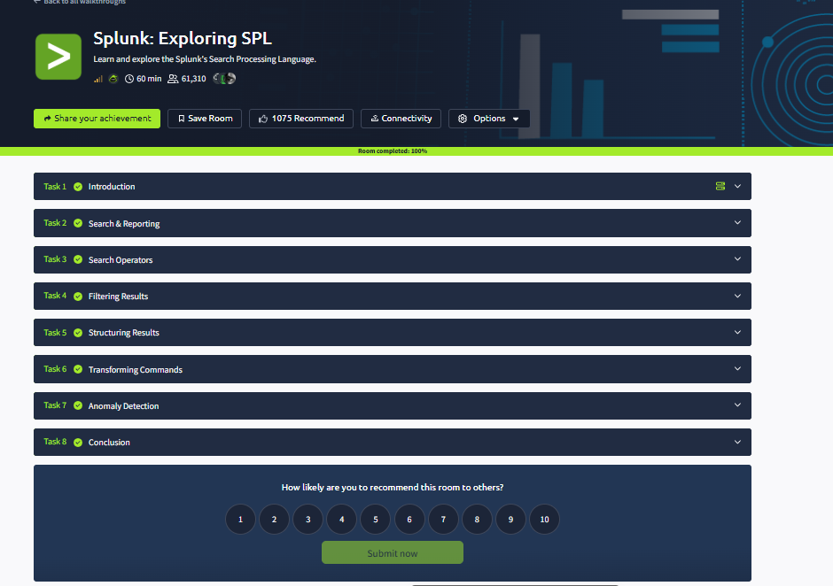

15. CONCLUSION
I successfully completed the TryHackMe Splunk: Exploring SPL lab.
This lab helped me understand how to use Search Processing Language to search, filter, structure and analyze security logs.
I learned important SPL commands such as search, fields, table, stats, eval, eventstats, top, rare, regex and iplocation.
I also understood how subsearches help correlate related events and how anomaly detection helps identify unusual login behaviour.
Overall, this lab improved my understanding of Splunk and its practical use in SOC operations, security monitoring, threat detection and incident investigation.

